**Name:**

1. **Service times**

|  |  |
| --- | --- |
| Name of service center | Service Time (Sk) |
| *AuthenticationServer* | **0.02** |
| *ContentWritingServer* | **0.4** |
| *LoggingServer* | **0.09995** |

1. **Simulation results**

**Screenshot:**

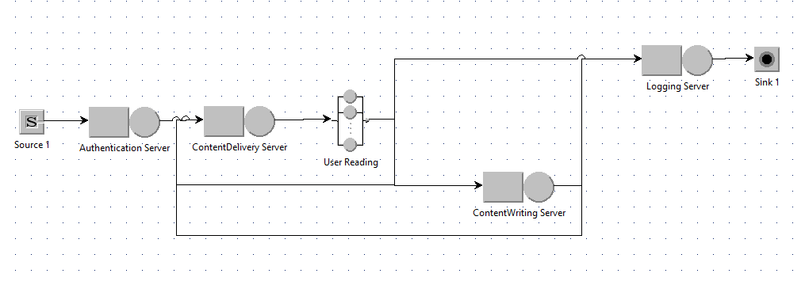

|  |  |  |
| --- | --- | --- |
| Name of service center | Utilization | Throughput |
| *AuthenticationServer* | **0.00789** | **0.3965** |
| *ContentDeliveryServer* | **0.40** | **1.3495** |
| *ContentWritingServer* | **0.04** | **0.1116** |
| *LoggingServer* | **0.0393** | **0.3933** |

|  |
| --- |
| 1028 |

Average System Response Time:

|  |
| --- |
| 2.56 |

Average time that a student is waiting for a reply from the system during a learning session:

1. **System upgrade**

|  |  |  |  |
| --- | --- | --- | --- |
| Name of service center | Minimum number of resources | Utilization | Throughput |
| *AuthenticationServer* | **1** | **0.00807** | **0.3960** |
| *ContentDeliveryServer* | **1** | **0.6752** | **2.3035** |
| *ContentWritingServer* | **1** | **0.0453** | **0.1139** |
| *LoggingServer* | **1** | **0.0396** | **0.3950** |

|  |
| --- |
| 1710 |

Average System Response Time:

**Bonus points:**

$$D_{4} = V_{4}×S_{4}=\frac{C_{4}}{C}×\frac{B_{4}}{C_{4}}=\frac{B_{4}}{C}=\frac{B_{4}}{X×T}=\frac{U_{4}}{X}$$

$$U_{4} = 0.04$$

$$D_{4} = \frac{U_{4}}{X}= \frac{0.04}{0.3965}=0.1$$

$$X_{4} = \frac{U_{4}}{S_{4}}= \frac{0.189888}{0.4}=0.189888$$